**CS590-BigData Analytics and Apps – (Summer 2014)**

**Lab 2: Report**

**Submitted By: Gireshbabu (16137268)**

Step1:

Read the sensor data to the file Sensor.txt in the device data folder

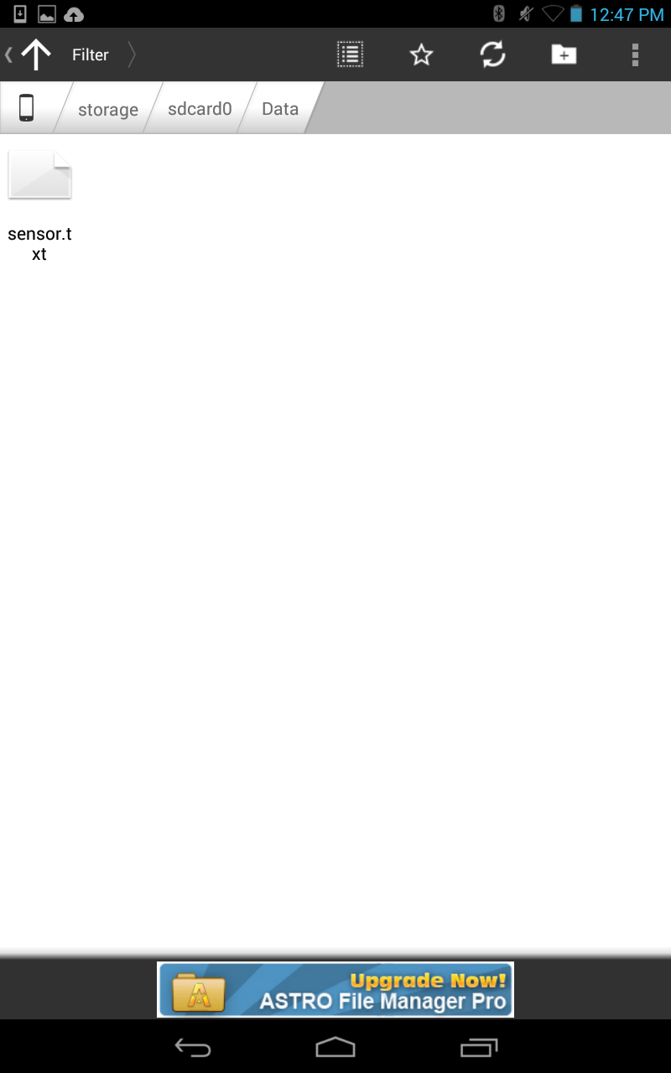

When we open the sensor.txt file we can see the sensor data readings in the file

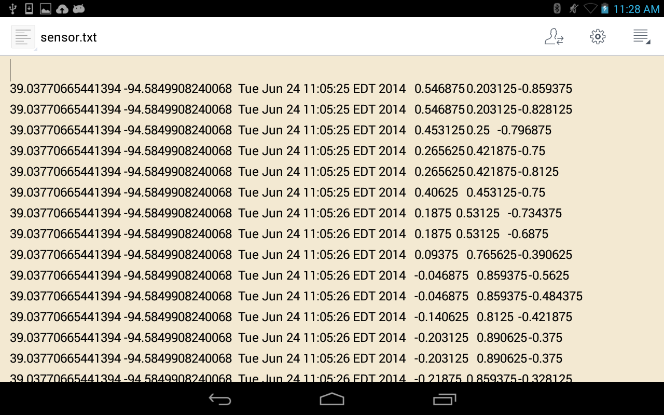

The above image shows the sensor data in the sensor.txt file which displays the latitude and longitude, timestamp and the x,y,z axes of accelerometer data

Now read this file with the HBASE client application

First create table in the “SensorTagLab2” in Hbase

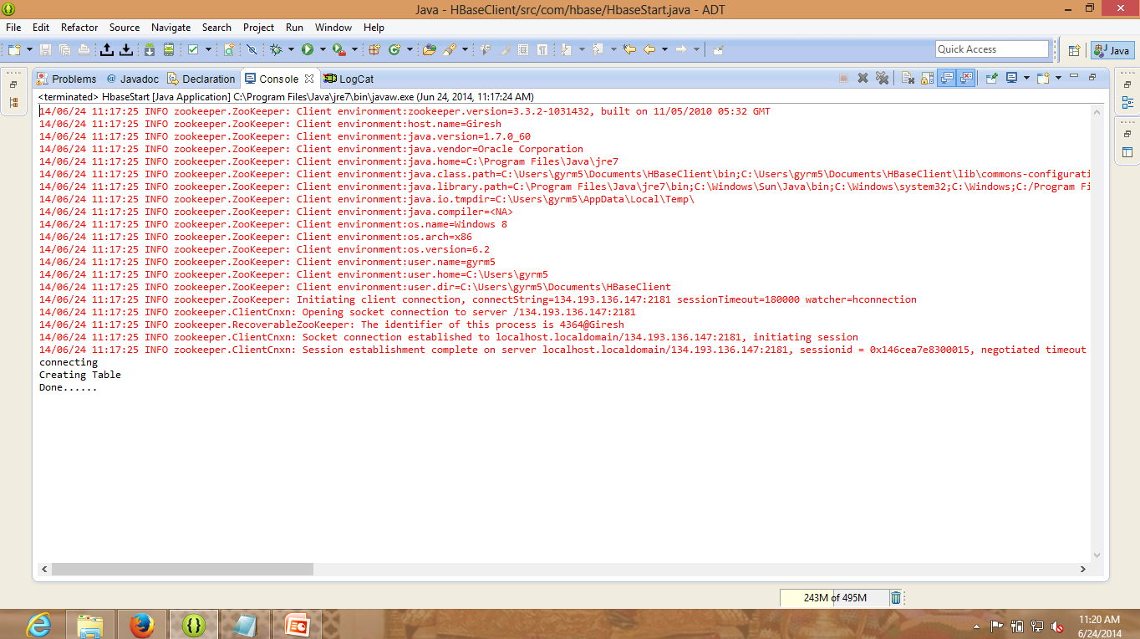Check the creation of table in the HBASE to see whether the table is created or not with the column heading

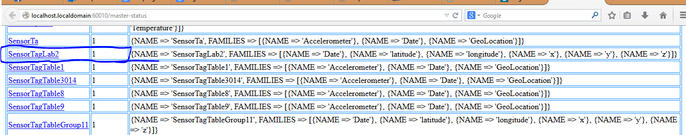

The table is now created on HBASE now we need to insert values into the table

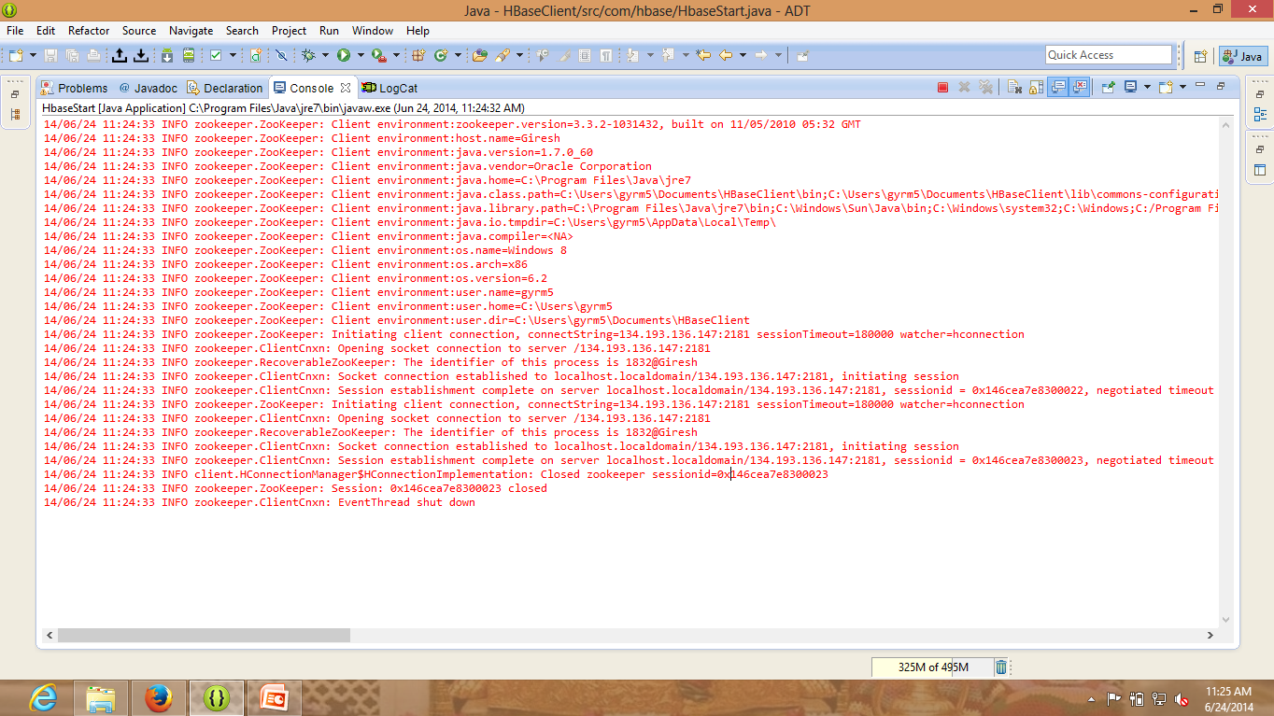

The data from the file is inserted into the table

Now check the values of the table by retrieving the table columns

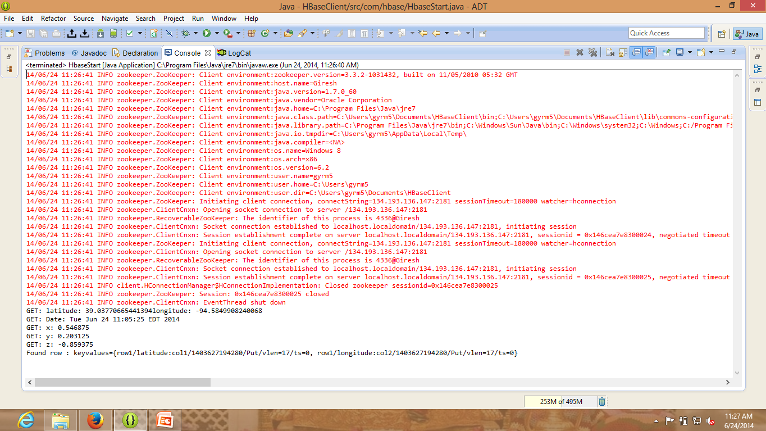

There are the results of the text file we created and retrieved from the HBASE table.